**PROJECT DESIGN PHASE II**

**TECHNOLOGY STACK (ARCHITECTURE AND STACK)**

|  |  |
| --- | --- |
| DATE | 09 November 2022 |
| TEAM ID | PNT2022TMID07611 |
| PROJECT NAME | Inventory Management System for Retailers |
| MAXIMUM MARKS | 4 MARKS |

**TECHNICAL ARCHITECTURE:**

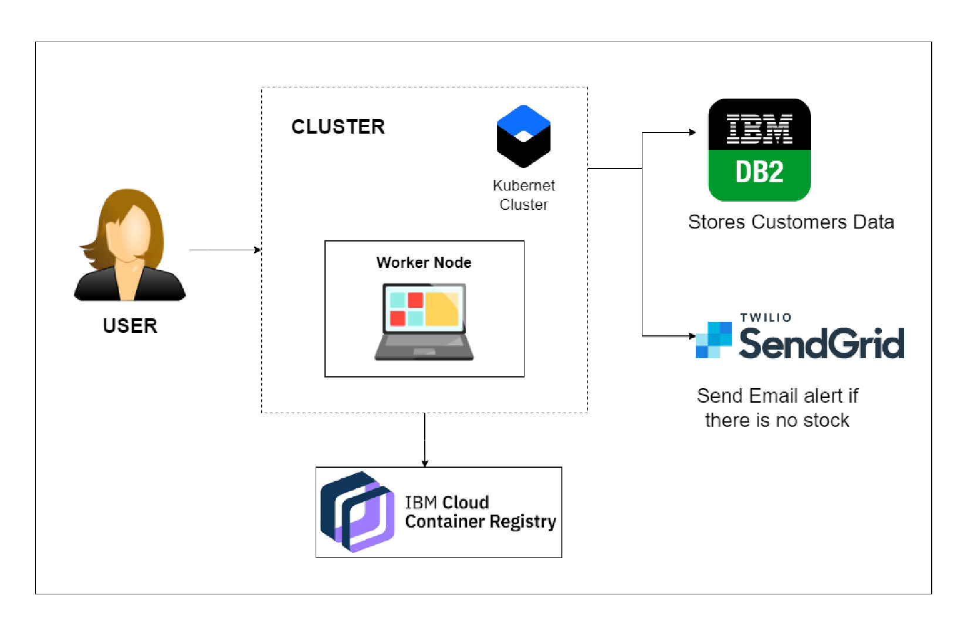

**Table 1: Components & Technologies**:

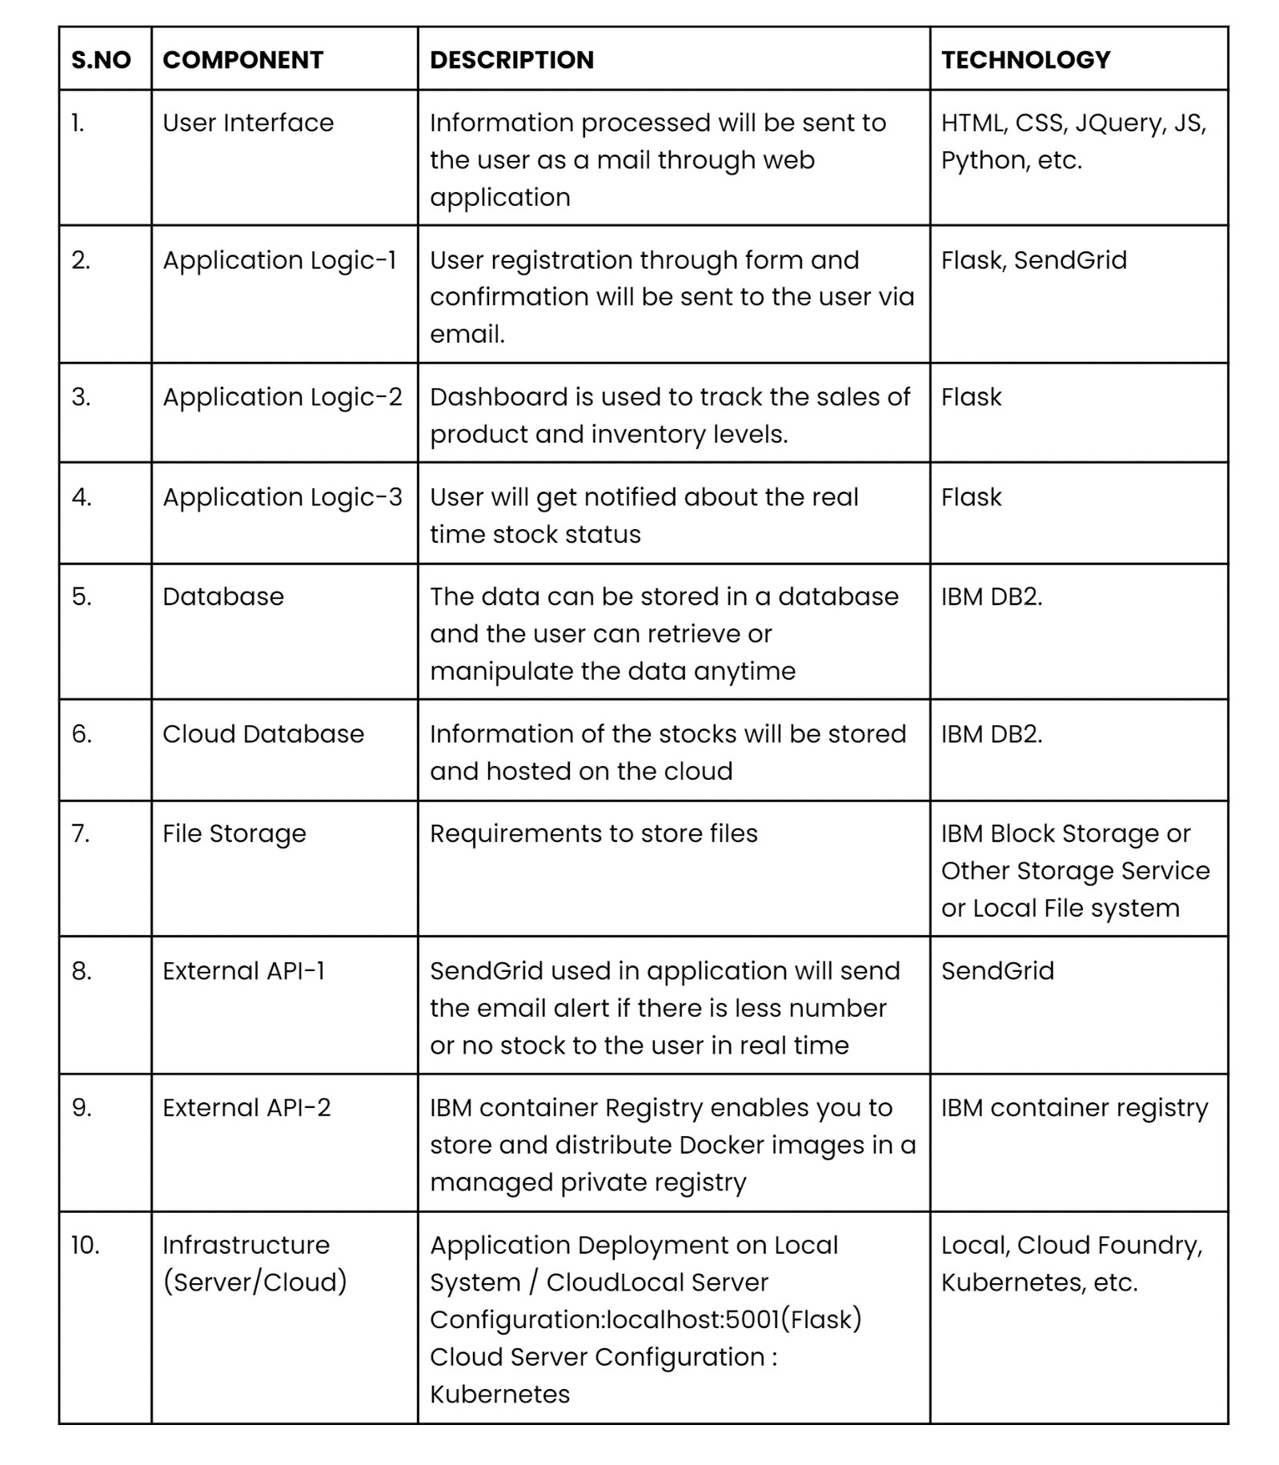

**Table-2: Application Characteristics**:

